Datos financieros: modelos vectoriales autorregresivos

J. Ramajo

2020

library(car)

library(vars)

library(tseries)

library(dynlm)  
library(FinTS)  
#  
load("TIPOS_CAMB.RData")  
TIPOS_CAMB_ts <- ts(monedas[,2:7], frequency=365, start=c(1998, 348))   
plot(TIPOS_CAMB_ts)

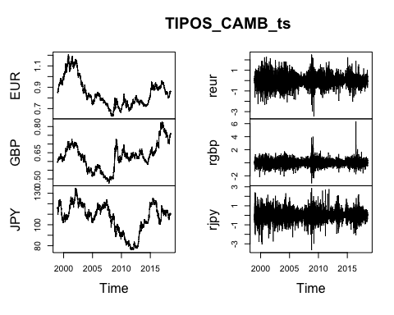

#  
EurUsd <- TIPOS_CAMB_ts[,"EUR"]  
GbpUsd <- TIPOS_CAMB_ts[,"GBP"]  
JpyUsd <- TIPOS_CAMB_ts[,"JPY"]  
# ts.plot(XUsd, ylab="Tipo de cambio X frente al dólar")  
#  
rEurUsd <- TIPOS_CAMB_ts[,"reur"]  
rGbpUsd <- TIPOS_CAMB_ts[,"rgbp"]  
rJpyUsd <- TIPOS_CAMB_ts[,"rjpy"]  
# ts.plot(rXUsd, ylab="Variaciones (returns) tipo de cambio X frente al dólar")  
#  
VARdat <- as.matrix(cbind(rEurUsd,rGbpUsd,rJpyUsd))  
#  
VARselect(VARdat,lag.max = 7, type = "const") # type = c("const", "trend", "both", "none")

## $selection  
## AIC(n) HQ(n) SC(n) FPE(n)   
## 4 2 1 4   
##   
## $criteria  
## 1 2 3 4 5  
## AIC(n) -5.433957556 -5.437768292 -5.438158556 -5.439454184 -5.438999454  
## HQ(n) -5.429977839 -5.430803787 -5.428209263 -5.426520103 -5.423080585  
## SC(n) -5.422397207 -5.417537682 -5.409257684 -5.401883051 -5.392758058  
## FPE(n) 0.004365784 0.004349179 0.004347482 0.004341853 0.004343827  
## 6 7  
## AIC(n) -5.437922320 -5.437313435  
## HQ(n) -5.419018663 -5.415424990  
## SC(n) -5.383010663 -5.373731516  
## FPE(n) 0.004348509 0.004351158

VAR2 <- VAR(VARdat,p=2)  
summary(VAR2)

##   
## VAR Estimation Results:  
## =========================   
## Endogenous variables: rEurUsd, rGbpUsd, rJpyUsd   
## Deterministic variables: const   
## Sample size: 7139   
## Log Likelihood: -10960.336   
## Roots of the characteristic polynomial:  
## 0.2727 0.2727 0.2069 0.0837 0.08119 0.08119  
## Call:  
## VAR(y = VARdat, p = 2)  
##   
##   
## Estimation results for equation rEurUsd:   
## ========================================   
## rEurUsd = rEurUsd.l1 + rGbpUsd.l1 + rJpyUsd.l1 + rEurUsd.l2 + rGbpUsd.l2 + rJpyUsd.l2 + const   
##   
## Estimate Std. Error t value Pr(>|t|)   
## rEurUsd.l1 0.1474966 0.0156777 9.408 <2e-16 ***  
## rGbpUsd.l1 -0.0183557 0.0170367 -1.077 0.281   
## rJpyUsd.l1 -0.0070978 0.0121200 -0.586 0.558   
## rEurUsd.l2 -0.0118082 0.0156628 -0.754 0.451   
## rGbpUsd.l2 0.0066229 0.0170320 0.389 0.697   
## rJpyUsd.l2 -0.0054273 0.0121196 -0.448 0.654   
## const 0.0001369 0.0054441 0.025 0.980   
## ---  
## Signif. codes: 0 '***' 0.001 '**' 0.01 '*' 0.05 '.' 0.1 ' ' 1  
##   
##   
## Residual standard error: 0.4599 on 7132 degrees of freedom  
## Multiple R-Squared: 0.01824, Adjusted R-squared: 0.01742   
## F-statistic: 22.09 on 6 and 7132 DF, p-value: < 2.2e-16   
##   
##   
## Estimation results for equation rGbpUsd:   
## ========================================   
## rGbpUsd = rEurUsd.l1 + rGbpUsd.l1 + rJpyUsd.l1 + rEurUsd.l2 + rGbpUsd.l2 + rJpyUsd.l2 + const   
##   
## Estimate Std. Error t value Pr(>|t|)   
## rEurUsd.l1 -0.025271 0.014058 -1.798 0.072285 .   
## rGbpUsd.l1 0.221362 0.015277 14.490 < 2e-16 ***  
## rJpyUsd.l1 -0.039016 0.010868 -3.590 0.000333 ***  
## rEurUsd.l2 0.046927 0.014045 3.341 0.000838 ***  
## rGbpUsd.l2 -0.067794 0.015272 -4.439 9.17e-06 ***  
## rJpyUsd.l2 0.003287 0.010868 0.302 0.762316   
## const 0.002826 0.004882 0.579 0.562715   
## ---  
## Signif. codes: 0 '***' 0.001 '**' 0.01 '*' 0.05 '.' 0.1 ' ' 1  
##   
##   
## Residual standard error: 0.4124 on 7132 degrees of freedom  
## Multiple R-Squared: 0.04083, Adjusted R-squared: 0.04002   
## F-statistic: 50.6 on 6 and 7132 DF, p-value: < 2.2e-16   
##   
##   
## Estimation results for equation rJpyUsd:   
## ========================================   
## rJpyUsd = rEurUsd.l1 + rGbpUsd.l1 + rJpyUsd.l1 + rEurUsd.l2 + rGbpUsd.l2 + rJpyUsd.l2 + const   
##   
## Estimate Std. Error t value Pr(>|t|)   
## rEurUsd.l1 0.0410613 0.0159078 2.581 0.00987 **   
## rGbpUsd.l1 -0.0708457 0.0172867 -4.098 4.21e-05 ***  
## rJpyUsd.l1 0.1324572 0.0122979 10.771 < 2e-16 ***  
## rEurUsd.l2 -0.0188915 0.0158927 -1.189 0.23460   
## rGbpUsd.l2 0.0249075 0.0172820 1.441 0.14956   
## rJpyUsd.l2 0.0149565 0.0122975 1.216 0.22394   
## const -0.0004126 0.0055240 -0.075 0.94046   
## ---  
## Signif. codes: 0 '***' 0.001 '**' 0.01 '*' 0.05 '.' 0.1 ' ' 1  
##   
##   
## Residual standard error: 0.4667 on 7132 degrees of freedom  
## Multiple R-Squared: 0.02082, Adjusted R-squared: 0.02   
## F-statistic: 25.28 on 6 and 7132 DF, p-value: < 2.2e-16   
##   
##   
##   
## Covariance matrix of residuals:  
## rEurUsd rGbpUsd rJpyUsd  
## rEurUsd 0.21155 0.12035 0.05812  
## rGbpUsd 0.12035 0.17010 0.03163  
## rJpyUsd 0.05812 0.03163 0.21780  
##   
## Correlation matrix of residuals:  
## rEurUsd rGbpUsd rJpyUsd  
## rEurUsd 1.0000 0.6344 0.2708  
## rGbpUsd 0.6344 1.0000 0.1643  
## rJpyUsd 0.2708 0.1643 1.0000

# Funciones de respuesta al impulso (IRFs)  
irf_VAR2 <- irf(VAR2)  
plot(irf_VAR2)

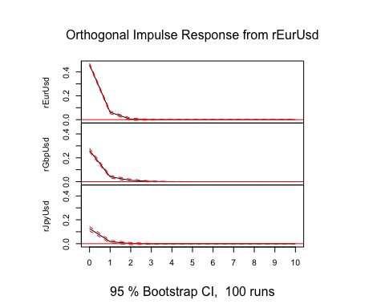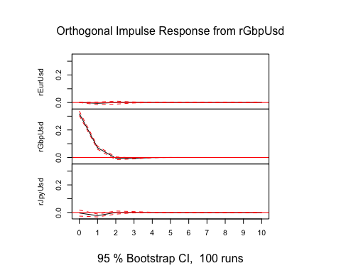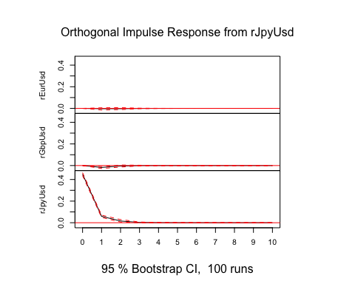

# Funciones de descomposición de la varianza del error de predicción (FEVDs)  
fevd_VAR2 <- fevd(VAR2)  
plot(fevd_VAR2)

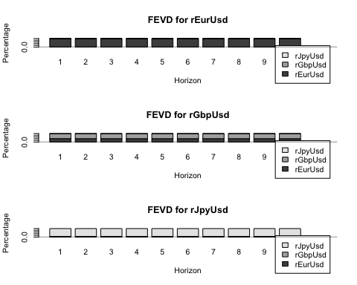

# Contrastes de causalidad de Granger  
grangertest(rEurUsd ~ rGbpUsd)

## Granger causality test  
##   
## Model 1: rEurUsd ~ Lags(rEurUsd, 1:1) + Lags(rGbpUsd, 1:1)  
## Model 2: rEurUsd ~ Lags(rEurUsd, 1:1)  
## Res.Df Df F Pr(>F)  
## 1 7137   
## 2 7138 -1 0.9912 0.3195

grangertest(rEurUsd ~ rJpyUsd)

## Granger causality test  
##   
## Model 1: rEurUsd ~ Lags(rEurUsd, 1:1) + Lags(rJpyUsd, 1:1)  
## Model 2: rEurUsd ~ Lags(rEurUsd, 1:1)  
## Res.Df Df F Pr(>F)  
## 1 7137   
## 2 7138 -1 0.4202 0.5169

causality(VAR2,cause = c("rGbpUsd","rJpyUsd"))$Granger

##   
## Granger causality H0: rGbpUsd rJpyUsd do not Granger-cause rEurUsd  
##   
## data: VAR object VAR2  
## F-Test = 0.44101, df1 = 4, df2 = 21396, p-value = 0.7791

#  
grangertest(rGbpUsd ~ rEurUsd)

## Granger causality test  
##   
## Model 1: rGbpUsd ~ Lags(rGbpUsd, 1:1) + Lags(rEurUsd, 1:1)  
## Model 2: rGbpUsd ~ Lags(rGbpUsd, 1:1)  
## Res.Df Df F Pr(>F)   
## 1 7137   
## 2 7138 -1 3.8834 0.04881 *  
## ---  
## Signif. codes: 0 '***' 0.001 '**' 0.01 '*' 0.05 '.' 0.1 ' ' 1

grangertest(rGbpUsd ~ rJpyUsd)

## Granger causality test  
##   
## Model 1: rGbpUsd ~ Lags(rGbpUsd, 1:1) + Lags(rJpyUsd, 1:1)  
## Model 2: rGbpUsd ~ Lags(rGbpUsd, 1:1)  
## Res.Df Df F Pr(>F)   
## 1 7137   
## 2 7138 -1 14.096 0.0001751 ***  
## ---  
## Signif. codes: 0 '***' 0.001 '**' 0.01 '*' 0.05 '.' 0.1 ' ' 1

causality(VAR2,cause = c("rEurUsd","rJpyUsd"))$Granger

##   
## Granger causality H0: rEurUsd rJpyUsd do not Granger-cause rGbpUsd  
##   
## data: VAR object VAR2  
## F-Test = 7.2478, df1 = 4, df2 = 21396, p-value = 7.917e-06

#  
grangertest(rJpyUsd ~ rEurUsd)

## Granger causality test  
##   
## Model 1: rJpyUsd ~ Lags(rJpyUsd, 1:1) + Lags(rEurUsd, 1:1)  
## Model 2: rJpyUsd ~ Lags(rJpyUsd, 1:1)  
## Res.Df Df F Pr(>F)  
## 1 7137   
## 2 7138 -1 5e-04 0.9815

grangertest(rJpyUsd ~ rGbpUsd)

## Granger causality test  
##   
## Model 1: rJpyUsd ~ Lags(rJpyUsd, 1:1) + Lags(rGbpUsd, 1:1)  
## Model 2: rJpyUsd ~ Lags(rJpyUsd, 1:1)  
## Res.Df Df F Pr(>F)   
## 1 7137   
## 2 7138 -1 9.69 0.00186 **  
## ---  
## Signif. codes: 0 '***' 0.001 '**' 0.01 '*' 0.05 '.' 0.1 ' ' 1

causality(VAR2,cause = c("rEurUsd","rGbpUsd"))$Granger

##   
## Granger causality H0: rEurUsd rGbpUsd do not Granger-cause rJpyUsd  
##   
## data: VAR object VAR2  
## F-Test = 4.3455, df1 = 4, df2 = 21396, p-value = 0.001634

# Modelización (G)ARCH  
hist(rEurUsd, main="", breaks=20, freq=FALSE, col="grey")

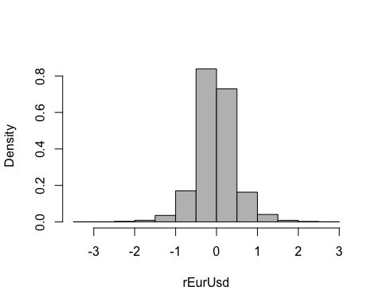

hist(rGbpUsd, main="", breaks=20, freq=FALSE, col="grey")

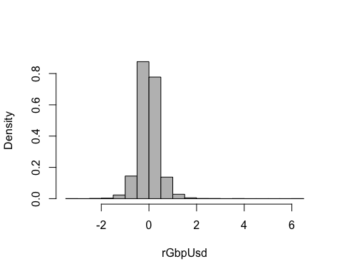

hist(rJpyUsd, main="", breaks=20, freq=FALSE, col="grey")

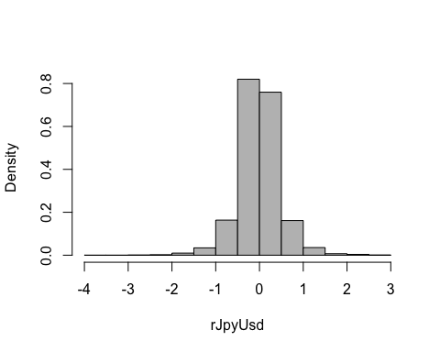

# Contraste de Engel de efectos ARCH  
S(VAR2_rEurUsd <- dynlm(rEurUsd ~ L(rEurUsd,1:2) + L(rGbpUsd,1:2) + L(rJpyUsd,1:2)))

## Call: dynlm(formula = rEurUsd ~ L(rEurUsd, 1:2) + L(rGbpUsd, 1:2) + L(rJpyUsd,  
## 1:2))  
##   
## Coefficients:  
## Estimate Std. Error t value Pr(>|t|)   
## (Intercept) 0.0001369 0.0054441 0.025 0.980   
## L(rEurUsd, 1:2)1 0.1474966 0.0156777 9.408 <2e-16 ***  
## L(rEurUsd, 1:2)2 -0.0118082 0.0156628 -0.754 0.451   
## L(rGbpUsd, 1:2)1 -0.0183557 0.0170367 -1.077 0.281   
## L(rGbpUsd, 1:2)2 0.0066229 0.0170320 0.389 0.697   
## L(rJpyUsd, 1:2)1 -0.0070978 0.0121200 -0.586 0.558   
## L(rJpyUsd, 1:2)2 -0.0054273 0.0121196 -0.448 0.654   
## ---  
## Signif. codes: 0 '***' 0.001 '**' 0.01 '*' 0.05 '.' 0.1 ' ' 1  
##   
## Residual standard deviation: 0.4599 on 7132 degrees of freedom  
## Multiple R-squared: 0.01824  
## F-statistic: 22.09 on 6 and 7132 DF, p-value: < 2.2e-16   
## AIC BIC   
## 9179.58 9234.56

ArchTest(VAR2_rEurUsd$residuals , lags = 1)

##   
## ARCH LM-test; Null hypothesis: no ARCH effects  
##   
## data: VAR2_rEurUsd$residuals  
## Chi-squared = 195.63, df = 1, p-value < 2.2e-16

#  
# Estimación de modelos GARCH para los residuos del modelo  
#  
summary(garch(VAR2_rEurUsd$residuals,c(0,1)))

##   
## ***** ESTIMATION WITH ANALYTICAL GRADIENT *****   
##   
##   
## I INITIAL X(I) D(I)  
##   
## 1 2.008019e-01 1.000e+00  
## 2 5.000000e-02 1.000e+00  
##   
## IT NF F RELDF PRELDF RELDX STPPAR D*STEP NPRELDF  
## 0 1 -2.078e+03  
## 1 3 -2.108e+03 1.39e-02 6.35e-02 2.4e-01 1.3e+04 1.0e-01 4.25e+02  
## 2 5 -2.132e+03 1.14e-02 4.50e-02 1.4e-01 2.1e+00 5.0e-02 8.48e+02  
## 3 6 -2.164e+03 1.46e-02 1.42e-02 1.2e-01 2.0e+00 5.0e-02 8.28e+01  
## 4 7 -2.168e+03 2.15e-03 3.24e-03 1.1e-01 2.0e+00 5.0e-02 3.72e+00  
## 5 10 -2.168e+03 1.93e-05 3.49e-05 1.8e-03 8.3e+00 8.9e-04 4.84e-02  
## 6 11 -2.168e+03 5.63e-07 1.02e-06 1.8e-03 2.0e+00 8.9e-04 2.50e-04  
## 7 14 -2.168e+03 1.53e-08 2.89e-08 5.2e-05 9.4e+00 2.6e-05 9.90e-07  
## 8 16 -2.168e+03 4.06e-09 6.46e-09 1.4e-04 3.5e+00 7.0e-05 3.32e-08  
## 9 18 -2.168e+03 1.27e-09 3.04e-09 5.9e-05 1.4e+00 3.0e-05 3.85e-09  
## 10 19 -2.168e+03 3.43e-10 3.46e-10 8.3e-06 0.0e+00 4.2e-06 3.46e-10  
## 11 20 -2.168e+03 1.59e-13 1.67e-13 1.0e-06 0.0e+00 5.1e-07 1.67e-13  
##   
## ***** RELATIVE FUNCTION CONVERGENCE *****  
##   
## FUNCTION -2.168492e+03 RELDX 1.042e-06  
## FUNC. EVALS 20 GRAD. EVALS 12  
## PRELDF 1.671e-13 NPRELDF 1.671e-13  
##   
## I FINAL X(I) D(I) G(I)  
##   
## 1 1.640543e-01 1.000e+00 -1.730e-05  
## 2 2.417211e-01 1.000e+00 -5.133e-05

##   
## Call:  
## garch(x = VAR2_rEurUsd$residuals, order = c(0, 1))  
##   
## Model:  
## GARCH(0,1)  
##   
## Residuals:  
## Min 1Q Median 3Q Max   
## -6.383794 -0.446486 -0.005734 0.442498 5.297992   
##   
## Coefficient(s):  
## Estimate Std. Error t value Pr(>|t|)   
## a0 0.164054 0.002264 72.46 <2e-16 ***  
## a1 0.241721 0.012913 18.72 <2e-16 ***  
## ---  
## Signif. codes: 0 '***' 0.001 '**' 0.01 '*' 0.05 '.' 0.1 ' ' 1  
##   
## Diagnostic Tests:  
## Jarque Bera Test  
##   
## data: Residuals  
## X-squared = 2467.9, df = 2, p-value < 2.2e-16  
##   
##   
## Box-Ljung test  
##   
## data: Squared.Residuals  
## X-squared = 1.7918, df = 1, p-value = 0.1807

#  
summary(garch(VAR2_rEurUsd$residuals,c(1,1)))

##   
## ***** ESTIMATION WITH ANALYTICAL GRADIENT *****   
##   
##   
## I INITIAL X(I) D(I)  
##   
## 1 1.902334e-01 1.000e+00  
## 2 5.000000e-02 1.000e+00  
## 3 5.000000e-02 1.000e+00  
##   
## IT NF F RELDF PRELDF RELDX STPPAR D*STEP NPRELDF  
## 0 1 -2.080e+03  
## 1 3 -2.085e+03 2.34e-03 6.57e-02 2.6e-01 1.4e+04 1.0e-01 4.50e+02  
## 2 4 -2.137e+03 2.43e-02 6.04e-02 1.5e-01 2.1e+00 5.0e-02 9.45e+02  
## 3 5 -2.165e+03 1.31e-02 1.32e-02 1.3e-01 2.0e+00 5.0e-02 9.41e+01  
## 4 6 -2.170e+03 2.31e-03 3.22e-03 1.1e-01 2.0e+00 5.0e-02 2.77e+00  
## 5 9 -2.170e+03 2.02e-05 3.61e-05 1.7e-03 7.5e+00 8.4e-04 6.53e-02  
## 6 10 -2.170e+03 1.62e-06 1.83e-06 1.5e-03 2.0e+00 8.4e-04 5.12e-03  
## 7 11 -2.170e+03 3.70e-06 4.72e-06 3.5e-03 2.0e+00 1.7e-03 3.84e-03  
## 8 12 -2.170e+03 2.25e-06 3.04e-06 3.3e-03 2.0e+00 1.7e-03 1.32e-03  
## 9 13 -2.170e+03 2.17e-06 3.73e-06 2.6e-03 2.0e+00 1.7e-03 3.39e-04  
## 10 14 -2.170e+03 1.07e-06 1.57e-06 2.9e-03 2.0e+00 1.7e-03 1.43e-04  
## 11 18 -2.170e+03 6.23e-08 1.28e-07 1.3e-04 2.5e+00 7.6e-05 3.43e-05  
## 12 19 -2.170e+03 6.37e-08 6.76e-08 1.1e-04 2.0e+00 7.6e-05 1.14e-05  
## 13 20 -2.170e+03 8.85e-08 9.27e-08 3.2e-04 2.0e+00 1.5e-04 1.09e-05  
## 14 21 -2.170e+03 1.49e-07 1.73e-07 5.8e-04 2.0e+00 3.0e-04 8.78e-06  
## 15 22 -2.170e+03 1.68e-07 3.58e-07 1.3e-03 1.9e+00 6.0e-04 7.03e-06  
## 16 23 -2.170e+03 4.69e-08 2.78e-07 1.2e-03 2.0e+00 6.0e-04 1.45e-05  
## 17 24 -2.170e+03 4.39e-07 5.92e-07 1.3e-03 2.0e+00 6.0e-04 2.58e-05  
## 18 25 -2.170e+03 1.48e-07 2.14e-07 1.2e-03 1.9e+00 6.0e-04 6.09e-06  
## 19 26 -2.170e+03 5.66e-08 1.24e-07 1.2e-03 1.3e+00 6.0e-04 4.05e-07  
## 20 27 -2.170e+03 2.75e-08 3.62e-08 6.3e-04 0.0e+00 3.3e-04 3.62e-08  
## 21 28 -2.170e+03 7.71e-10 5.92e-10 6.6e-05 0.0e+00 3.2e-05 5.92e-10  
## 22 29 -2.170e+03 2.73e-11 4.87e-12 5.2e-06 0.0e+00 3.1e-06 4.87e-12  
## 23 30 -2.170e+03 -1.66e-12 3.53e-15 2.0e-07 0.0e+00 9.8e-08 3.53e-15  
##   
## ***** RELATIVE FUNCTION CONVERGENCE *****  
##   
## FUNCTION -2.170003e+03 RELDX 1.961e-07  
## FUNC. EVALS 30 GRAD. EVALS 23  
## PRELDF 3.532e-15 NPRELDF 3.532e-15  
##   
## I FINAL X(I) D(I) G(I)  
##   
## 1 1.503901e-01 1.000e+00 1.137e-03  
## 2 2.370137e-01 1.000e+00 1.077e-04  
## 3 6.756497e-02 1.000e+00 1.898e-04

##   
## Call:  
## garch(x = VAR2_rEurUsd$residuals, order = c(1, 1))  
##   
## Model:  
## GARCH(1,1)  
##   
## Residuals:  
## Min 1Q Median 3Q Max   
## -6.43028 -0.44755 -0.00577 0.44486 5.34298   
##   
## Coefficient(s):  
## Estimate Std. Error t value Pr(>|t|)   
## a0 0.150390 0.005257 28.607 < 2e-16 ***  
## a1 0.237014 0.012798 18.520 < 2e-16 ***  
## b1 0.067565 0.024704 2.735 0.00624 **   
## ---  
## Signif. codes: 0 '***' 0.001 '**' 0.01 '*' 0.05 '.' 0.1 ' ' 1  
##   
## Diagnostic Tests:  
## Jarque Bera Test  
##   
## data: Residuals  
## X-squared = 2476.4, df = 2, p-value < 2.2e-16  
##   
##   
## Box-Ljung test  
##   
## data: Squared.Residuals  
## X-squared = 1.5666, df = 1, p-value = 0.2107